ASSIGNMENT 6
1)
#include<iostream>
using namespace std;

class Node
{
public:
int val;
Node *next;
Node()
{
val=0;
next=NULL;
}
Node(int val)
{
this->val=val;
next=NULL;
}
};

class CircularLinkedList
{
public:
Node *start;
int size;
CircularLinkedList()
{
start=NULL;
size=0;
}
void insertAtBeginning(int data)
{
Node *nnode=new Node(data);
if(start==NULL)
{
start=nnode;
nnode->next=start;
}
else
{
nnode->next=start;
Node *temp=start;
while(temp->next!=start)
{
temp=temp->next;
}
temp->next=nnode;
start=nnode;
cout<<data<<" inserted Successfully at Beginning"<<endl;
}
size++;
}
void insertAtEnd(int data)
{
Node *nnode=new Node(data);
if(start==NULL)
{
start=nnode;
nnode->next=start;
}
else
{
Node *temp=start;
while(temp->next!=start)
{
temp=temp->next;
}
temp->next=nnode;
nnode->next=start;
cout<<data<<" inserted Successfully at End"<<endl;
}
size++;
}
void insertInBetween(int data, int pos)
{
Node *temp=start;
while(temp->next->val!=pos)
{
temp=temp->next;
}
Node *nnode=new Node(data);
Node *t=temp->next;
temp->next=nnode;
nnode->next=t;
cout<<data<<" inserted before "<<pos<<endl;
size++;
}
void deleteNode(int data)
{
if(start==NULL)
{
cout<<"List is Empty!!!"<<endl;
return;
}
if(start->val==data)
{
Node *temp=start;
Node *t=start;
start=start->next;
temp=temp->next;
while(temp->next!=t)
{
temp=temp->next;
}
temp->next=start;
cout<<data<<" deleted successfully from the list"<<endl;
delete(t);
return;
}
Node *prev=start;
Node *temp=start->next;
while(temp->next!=start)
{
if(temp->val==data)
{
prev->next=temp->next;
delete(temp);
cout<<data<<" deleted successfully from the list"<<endl;
return;
}
prev=temp;
temp=temp->next;
}
if(temp->val==data)
{
prev->next=start;
delete(temp);
cout<<data<<" deleted successfully from the list"<<endl;
return;
}
cout<<data<<" Not Found!!!"<<endl;
}
void search(int data)
{
if(start==NULL)
{
cout<<"List is Empty!!!"<<endl;
return;
}
Node *temp=start;
do
{
if(temp->val==data)
{
cout<<data<<" found in the list"<<endl;
return;
}
temp=temp->next;
}while(temp!=start);
cout<<data<<" Not Found!!!"<<endl;
}
void display()
{
if(start==NULL)
{
cout<<"List is Empty!!!"<<endl;
return;
}
Node *temp=start;
cout<<"-------------Printing Circular Linked List---------------"<<endl;
cout<<"start-->";
do
{
cout<<temp->val<<"-->";
temp=temp->next;
} while (temp!=start);
cout<<"start"<<endl;
}
};

int main()
{
CircularLinkedList cll;
while(1)
{
cout<<"Press 1 to Insert At Beginning"<<endl;
cout<<"Press 2 to Insert At End"<<endl;
cout<<"Press 3 to Insert Before Given Position"<<endl;
cout<<"Press 4 to Delete an Element"<<endl;
cout<<"Press 5 to Search for an Element"<<endl;
cout<<"Press 6 to Display"<<endl;
cout<<"Press 7 to Exit"<<endl;
cout<<"Enter your choice: ";
int choice;
cin>>choice;
if(choice==7)
{
break;
}
switch(choice)
{
case 1:
{
int data;
cout<<"Enter the element you want to insert: ";
cin>>data;
cout<<endl;
cll.insertAtBeginning(data);
break;
}
case 2:
{
int data;
cout<<"Enter the element you want to insert: ";
cin>>data;
cout<<endl;
cll.insertAtEnd(data);
break;
}
case 3:
{
int data;
cout<<"Enter the element you want to insert: ";
cin>>data;
cout<<endl;
cout<<"Enter the position before which you want to insert: ";
int pos;
cin>>pos;
cout<<endl;
cll.insertInBetween(data,pos);
break;
}
case 4:
{
int data;
cout<<"Enter the element you want to delete: ";
cin>>data;
cout<<endl;
cll.deleteNode(data);
}
case 5:
{
int data;
cout<<"Enter the element you want to delete: ";
cin>>data;
cout<<endl;
cll.search(data);
}
case 6:
{
cll.display();
}
}
}
}
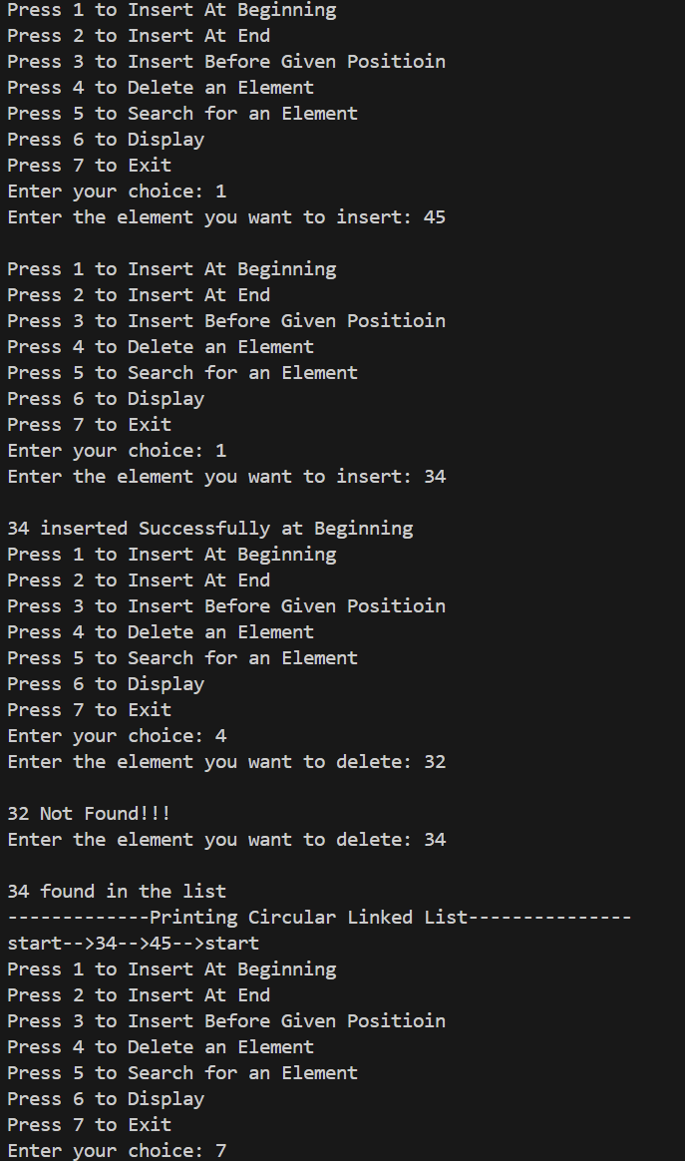

2) #include <iostream>
using namespace std;

class CircularNode {
public:
int data;
CircularNode* next;

CircularNode(int val) {
data = val;
next = nullptr;
}
};

class CircularLinkedList {
private:
CircularNode* head;

public:
CircularLinkedList() {
head = nullptr;
}

void insertAtEnd(int value) {
CircularNode* newNode = new CircularNode(value);
if (!head) {
head = newNode;
newNode->next = head;
} else {
CircularNode* temp = head;
while (temp->next != head) {
temp = temp->next;
}
temp->next = newNode;
newNode->next = head;
}
}

void displayWithoutHeadAtEnd() {
if (!head) {
cout << "List is empty!" << endl;
return;
}

CircularNode* temp = head;
do {
cout << temp->data << " ";
temp = temp->next;
} while (temp != head);

cout << endl;
}

void displayWithHeadAtEnd() {
if (!head) {
cout << "List is empty!" << endl;
return;
}

CircularNode* temp = head;
do {
cout << temp->data << " ";
temp = temp->next;
} while (temp != head);

cout << head->data << endl;
}
};

int main() {
CircularLinkedList cll;
cll.insertAtEnd(20);
cll.insertAtEnd(100);
cll.insertAtEnd(40);
cll.insertAtEnd(80);
cll.insertAtEnd(60);

cout << "Circular Linked List (without repeated head node): ";
cll.displayWithoutHeadAtEnd();

cout << "Circular Linked List (with repeated head node): ";
cll.displayWithHeadAtEnd();

return 0;
}

3a)
#include <iostream>
using namespace std;

class DoublyNode {
public:
int data;
DoublyNode* next;
DoublyNode* prev;

DoublyNode(int val) {
data = val;
next = nullptr;
prev = nullptr;
}
};

class DoublyLinkedList {
private:
DoublyNode* head;

public:
DoublyLinkedList() {
head = nullptr;
}

void insertAtEnd(int value) {
DoublyNode* newNode = new DoublyNode(value);
if (!head) {
head = newNode;
} else {
DoublyNode* temp = head;
while (temp->next) {
temp = temp->next;
}
temp->next = newNode;
newNode->prev = temp;
}
}

int size() {
int count = 0;
DoublyNode* temp = head;
while (temp) {
count++;
temp = temp->next;
}
return count;
}

void display() {
if (!head) {
cout << "List is empty!" << endl;
return;
}

DoublyNode* temp = head;
while (temp) {
cout << temp->data << " ";
temp = temp->next;
}
cout << endl;
}
};

int main() {
DoublyLinkedList dll;

dll.insertAtEnd(10);
dll.insertAtEnd(20);
dll.insertAtEnd(30);
dll.insertAtEnd(40);

cout << "Doubly Linked List: ";
dll.display();

cout << "Size of Doubly Linked List: " << dll.size() << endl;

return 0;
}
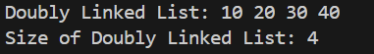

3b) #include <iostream>
using namespace std;

class CircularNode {
public:
int data;
CircularNode* next;

CircularNode(int val) {
data = val;
next = nullptr;
}
};

class CircularLinkedList {
private:
CircularNode* head;

public:
CircularLinkedList() {
head = nullptr;
}

void insertAtEnd(int value) {
CircularNode* newNode = new CircularNode(value);
if (!head) {
head = newNode;
newNode->next = head;
} else {
CircularNode* temp = head;
while (temp->next != head) {
temp = temp->next;
}
temp->next = newNode;
newNode->next = head;
}
}

int size() {
if (!head) return 0;
int count = 1;
CircularNode* temp = head->next;

while (temp != head) {
count++;
temp = temp->next;
}

return count;
}

void display() {
if (!head) {
cout << "List is empty!" << endl;
return;
}

CircularNode* temp = head;
do {
cout << temp->data << " ";
temp = temp->next;
} while (temp != head);
cout << endl;
}
};

int main() {
CircularLinkedList cll;

cll.insertAtEnd(20);
cll.insertAtEnd(30);
cll.insertAtEnd(80);
cll.insertAtEnd(90);
cll.insertAtEnd(23);

cout << "Circular Linked List: ";
cll.display();

cout << "Size of Circular Linked List: " << cll.size() << endl;

return 0;
}

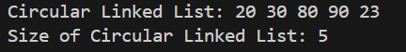

4)
#include <iostream>
using namespace std;

class DoublyNode {
public:
char data;
DoublyNode* next;
DoublyNode* prev;

DoublyNode(char val) {
data = val;
next = nullptr;
prev = nullptr;
}
};

class DoublyLinkedList {
private:
DoublyNode* head;
DoublyNode* tail;

public:
DoublyLinkedList() {
head = nullptr;
tail = nullptr;
}

void insertAtEnd(char value) {
DoublyNode* newNode = new DoublyNode(value);
if (!head) {
head = newNode;
tail = newNode;
} else {
tail->next = newNode;
newNode->prev = tail;
tail = newNode;
}
}

bool isPalindrome() {
if (!head) {
return true;
}

DoublyNode* start = head;
DoublyNode* end = tail;

while (start != end && start->prev != end) {
if (start->data != end->data) {
return false;
}
start = start->next;
end = end->prev;
}

return true;
}

void display() {
if (!head) {
cout << "List is empty!" << endl;
return;
}

DoublyNode* temp = head;
while (temp) {
cout << temp->data << " ";
temp = temp->next;
}
cout << endl;
}
};

int main() {
DoublyLinkedList dll;
char value;
char cont;

cout << "Enter characters for the doubly linked list:" << endl;
do {
cout << "Enter character: ";
cin >> value;
dll.insertAtEnd(value);

cout << "Do you want to enter another character? (y/n): ";
cin >> cont;
} while (cont == 'y' || cont == 'Y');

cout << "Doubly Linked List: ";
dll.display();

if (dll.isPalindrome()) {
cout << "The list is a palindrome." << endl;
} else {
cout << "The list is not a palindrome." << endl;
}

return 0;
}
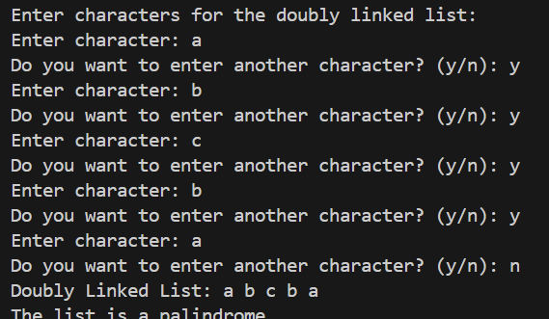

5)
#include<iostream>
using namespace std;

class Node {
public:
int val;
Node* next;

Node(int val) {
this->val = val;
this->next = nullptr;
}
};

bool isCircular(Node* head) {
if (head == nullptr) {
return false;
}

Node* slow_ptr = head;
Node* fast_ptr = head;

while (fast_ptr != nullptr && fast_ptr->next != nullptr) {
slow_ptr = slow_ptr->next;
fast_ptr = fast_ptr->next->next;

if (slow_ptr == fast_ptr) {
return true;
}
}

return false;
}

void printList(Node* head) {
if (head == nullptr) {
cout << "The list is empty." << endl;
return;
}
Node* temp = head;
cout << "Linked List: ";
while (temp != nullptr) {
cout << temp->val << " -> ";
temp = temp->next;
}
cout << "NULL" << endl;
}

void printCircularList(Node* head) {
if (head == nullptr) {
cout << "The list is empty." << endl;
return;
}
Node* temp = head;
cout << "Circular Linked List: ";
while (temp != nullptr) {
cout << temp->val << " -> ";
temp = temp->next;
if (temp == head) break;
}
cout << "(back to start)" << endl;
}

int main() {
Node* head1 = new Node(1);
Node* second1 = new Node(2);
Node* third1 = new Node(3);
Node* fourth1 = new Node(4);

head1->next = second1;
second1->next = third1;
third1->next = fourth1;
fourth1->next = head1;

cout << "Case 1: Circular Linked List" << endl;
printCircularList(head1);

if (isCircular(head1)) {
cout << "The linked list is circular." << endl;
} else {
cout << "The linked list is not circular." << endl;
}

Node* head2 = new Node(1);
Node* second2 = new Node(2);
Node* third2 = new Node(3);
Node* fourth2 = new Node(4);

head2->next = second2;
second2->next = third2;
third2->next = fourth2;
fourth2->next = nullptr;

cout << "\nCase 2: Non-Circular Linked List" << endl;
printList(head2);

if (isCircular(head2)) {
cout << "The linked list is circular." << endl;
} else {
cout << "The linked list is not circular." << endl;
}

return 0;
}
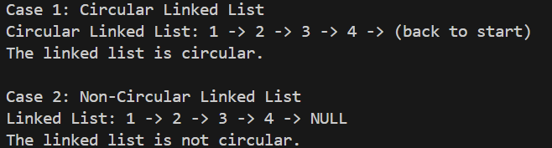

By :-> Nishant Bimra…

